**RESUMEAR: A WEB-BASED RESUME GENERATOR WITH AUGMENTED REALITY FEATURES**

**MARY CHEW JIA YI**

**A project report submitted in partial**

**fulfilment of the requirements for the award of**

**Bachelor of Software Engineering with Honours**

**University Malaysia of Computer Science and Engineering (UNIMY)**

**May 2019**

The copyright of this thesis belongs to the author under the terms of the copyright Act 1987 as qualified by the Intellectual Property Policy of University Malaysia of Computer Science and Engineering (UNIMY). Due acknowledgement shall always be made of the use of any material contained in, or derived from, this thesis.

© 2019, Name of Author. All rights reserved.

DECLARATION

I hereby declare that this project report is based on my original work except for citations and quotations which have been duly acknowledged. I also declare that it has not been previously and concurrently submitted for any other degree or award at University Malaysia of Computer Science and Engineering (UNIMY) or other institutions.

|  |  |  |
| --- | --- | --- |
| Signature | : |  |
| Name | : |  |
| ID No. | : |  |
| Date | : |  |

APPROVAL FOR SUBMISSION

I certify that this project report entitled **“TITLE TO BE THE SAME AS FRONT COVER, CAPITAL LETTER, BOLD”** was prepared by **STUDENT’S NAME** has met the required standard for submission in partial fulfilment of the requirements for the award of Bachelor of XXXXX at University Malaysia of Computer Science and Engineering (UNIMY).

Approved by,

|  |  |  |
| --- | --- | --- |
| Signature | : |  |
| Supervisor | : |  |
| Date | : |  |

Specially dedicated to

my beloved grandmother, mother and father

(this dedication page is optional)

ACKNOWLEDGEMENTS

I would like to thank everyone who had contributed to the successful completion of this project. I would like to express my gratitude to my research supervisor, Dr. XXXXX for his invaluable advice, guidance and his enormous patience throughout the development of the research.

In addition, I would also like to express my gratitude to my loving parent and friends who had helped and given me encouragement......

(This acknowledgements page is optional)......

**PROJECT TITLE IN CAPITAL LETTER**

**TITLE TO BE THE SAME AS FRONT COVER**

ABSTRACT

Many relief scenarios involve the discharge of a two-phase fluid mixture, and the proper method for sizing the relief valve for these conditions is the subject of considerable discussion. Sizing a valve is based on the flow through an isentropic nozzle, the pressure–density relation for the fluid properties, and a discharge coefficient (*Kd*) to match the calculated mass flux to that measured for the flow of air or water in the actual valve. For single-phase flow, this is straightforward, since the fluid properties are simple and measured values of *Kd* are available. For two-phase flow, the density–pressure relation is complex and no values of *Kd* are available, so a variety of ‘‘models’’ have been proposed in the literature to address this problem. Since the various models produce various results, the appropriate value of *Kd* required to match the model to the actual valve will depend on the model. This paper utilizes a simple, rigorous method for sizing relief valves for two-phase flow that utilizes the fluid properties directly and hence does not require a ‘‘model’’ for these properties. It is shown how this method can be applied to two-phase frozen or flashing (equilibrium or non-equilibrium) nozzle flows, and how the available values for *Kd* for single-phase flow can be used directly with this method, depending on the critical state of flow in the nozzle, to accurately predict two-phase flow in any valve. The calculations are compared with data from the literature for frozen air/water and flashing steam/water flows in actual safety relief valves.

TABLE OF CONTENTS

DECLARATION ii

APPROVAL FOR SUBMISSION iii

ACKNOWLEDGEMENTS v

ABSTRACT vi

TABLE OF CONTENTS vii

LIST OF TABLES ix

LIST OF FIGURES x

LIST OF SYMBOLS / ABBREVIATIONS xi

LIST OF APPENDICES xii

**CHAPTER TITLE PAGE**

1 INTRODUCTION 13

1.1 Background 13

1.2 Problem Statement 13

1.3 Aim and Objectives 14

1.4 Scope 15

1.5 Significance of the Project/Research 15

1.6 Organization of Thesis 15

2 LITERATURE REVIEW 16

2.1 Subsection Title 1 16

2.2 Subsection Title 2 16

2.3 Subsection Title 3 17

2.3.1 Sub-subsection Title 1 17

2.3.2 Sub-subsection Title 2 17

2.3.3 Sub-subsection Title 3 18

2.4 Subsection Title 4 18

3 METHODOLOGY 20

3.1 Subsection Title 1 20

3.2 Subsection Title 2 20

3.3 Sub-subsection Title 1 21

3.3.1 Sub-sub-subsection Title 1 21

4 IMPLEMENTATION OF DESIGN 22

4.1 Subsection Title 1 22

4.2 Subsection Title 2 22

4.3 Sub-subsection Title 1 23

4.3.1 Sub-sub-subsection Title 1 23

5 CONCLUSION 24

5.1 Subsection Title 1 24

5.2 Subsection Title 2 24

5.3 Sub-subsection Title 1 25

5.3.1 Sub-sub-subsection Title 1 25

REFERENCES 26

APPENDICES 27

LIST OF TABLES

|  |  |  |
| --- | --- | --- |
| **TABLE** | **TITLE** | **PAGE** |
| 2.1 | Processing Time (in hours) of Bread for Different Production Line in ABC Company | 4 |
| 2.2 | Processing Time for Different Production Line | 5 |
| 3.1 | Processing Time (in hours) of Bread for Different Production Line | 8 |
| 4.1 | Processing Time (in hours) of Bread for Different Production Line | 10 |

LIST OF FIGURES

|  |  |  |
| --- | --- | --- |
| **FIGURE** | **TITLE** | **PAGE** |
| 2.1 | University Malaysia of Computer Science and Engineering Logo | 6 |
| 3.1 | Reflection from Smooth Surface | 8 |
| 4.1 | UniMy Logo | 10 |

LIST OF SYMBOLS / ABBREVIATIONS

*cp* specific heat capacity, J/(kg⋅K)

*h* height, m

*Kd* discharge coefficient

*M* mass flow rate, kg/s

*P* pressure, kPa

*Pb* back pressure, kPa

*R* mass flow rate ratio

*T* temperature, K

*v* specific volume, m3

*α* homogeneous void fraction

*η* pressure ratio

*ρ* density, kg/m3

*ω* compressible flow parameter

ID inner diameter, m

MAP maximum allowable pressure, kPa

MAWP maximum allowable working pressure, kPa

OD outer diameter, m

RV relief valve

LIST OF APPENDICES

|  |  |  |
| --- | --- | --- |
| **APPENDIX** | **TITLE** | **PAGE** |
| A | Graphs | 14 |
| B | Computer Programme Listing | 15 |

## INTRODUCTION

### Background

A resume, or résumé is a document of several pages about a job applicant’s past employment history, education (Resume, n.d.), as well as accomplishments. It often supplies an employment objective as a summary of skills, knowledge, potential contributions, voluntary work, certifications and also relevant coursework. It is useful for the job applicants to apply for posted jobs of any fields when they come across the job opening (Heathfield, 2018).

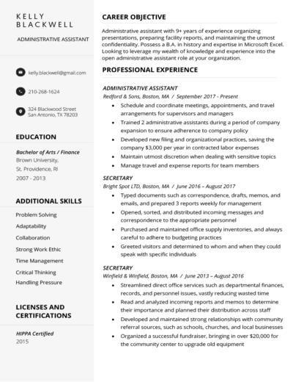

Figure 1.1 A typical resume

The importance of a resume is that job applicants can use it as a marketing tool to impress an employer because it outlines one’s background, skills and education that the employer will be able to see how their individual experiences can contribute to a company’s success (Resume, n.d.). However, when it comes to resume screening, an employer or a recruiter takes only 8-10 seconds or even less on average to screen their resumes before considering them to be shortlisted for pre-screen interviews. Hence, it means that to make a first impression to the employer, a well-written professional resume is required (Roo, 2015).

Augmented Reality, which is abbreviated as AR, is the technology that expands our physical world by adding layers of digital information onto it. Such digital information of any forms like sounds, videos and graphics. Another definition of AR is that a view of the physical real-world environment with superimposed computer-generated images that changes the perception of reality. AR is widely used in most fields like education, tourism, furniture, healthcare, manufacturing and the like (What is Augmented Reality (AR) and How does it work, n.d.). Examples of the popular AR applications are Pokémon Go, Google SkyMap and IKEA (Bonsor & Chandler, n.d.).

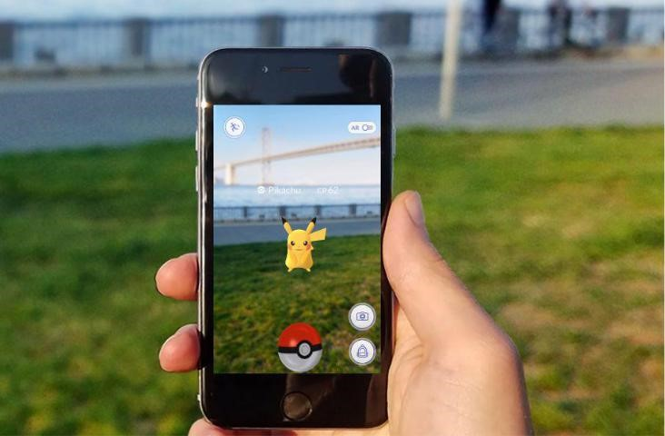

Figure 1.2 Pokémon Go with AR technology

### Problem Statement

Resume is an important tool to present one’s background and skillsets when it comes to job application. However, problems arise when job applicants want to write an ideal resume that stands out. One of the problems is the lack of experience of fresh graduates in building a resume. Most of them tend to make mistakes in building a resume (Mustafa, 2018) and end up producing a poorly-formatted unprofessional resume, which might not be catching employer’s eye.

Besides, job applicants who have numerous achievements and certifications would want to attempt the “one-size-fits-all” approach (Vogt, n.d.) that will cause a lengthy resume. An ideal resume is about one or two pages long and consists of three key elements like working experience, measurable achievements and educational background or professional training (Mustafa, 2018). Hence, it does not allow them to attach as many achievements, certifications and other important attachments as they possibly have.

Another problem is building a resume is the tedious work being laboured in it as it includes the processes of drafting, formatting and writing (Copeland, n.d.). A few ways of building a resume according to one’s preference are using existing online resume generator and also using any word processors.

### Aim and Objectives

The aim for the project is to develop a resume generator that allows job seekers to create a resume online and an AR technology as a supplement to the resume. Augmented digital elements such as videos, images and documents can be viewed in the resume through a camera of any mobile devices.

The objectives of this project are:

1. To study a comparative analysis of the existing online resume generators.
2. To develop a web-based application to generate an augmented reality resume as an interactive medium in job application and interviews.
3. To test the resume across various kinds of mobile devices.

### Scope

The target audience of this project is the job seekers. The project will be focused on the development of the resume generator website that produces an augmented reality resume to be viewed across different mobile devices.

Here will be the flow of the project:

1. Create an account and sign in the online resume generator application.
2. Create a blank resume of any one of the templates or themes.
3. Provide inputs about one’s personal details such as educational background, contact information and the like.
4. Upload any attachments of any kinds of multimedia elements such as audio, videos, pictures and documents.
5. Save, preview and download the final resume as PDF.
6. Scan the generated resume with any mobile devices with camera.

When scanning the resume, it will display 2D computer-generated perceptual information in the form of interactive digital elements and is able to play videos and audios as well as to view documents and pictures. To use the entire application, mobile devices, camera and Internet connection are required.

In this project, Ar.js and A-Frame will be the tools to do web augmented reality which are compatible in any web browsers regardless of the operating system. React.js will be used a frontend web framework while Node.js will be the backend web framework. MySQL will be the database application to store the information.

### Significance of the Project/Research

The project is to expect to enable the job seekers to create a resume easily and conveniently because a template of resume is prepared for them without the need to go through the processes of drafting and writing a resume. It is also to expect that they can view the digital media elements as augmented features in the resume through the camera.

### Organization of Thesis

The organization of the thesis are as follow.

1. Chapter 1: Introduction

To discuss about the background of resume and augmented reality. Besides, this section also provides a brief understanding about how the project will be developed and how AR is introduced in this project. It also explains the aim and objectives, scope and the significance of the project.

1. Chapter 2: Literature Review

To analyse and study the main components of this project such as resume, existing online resume generators and AR technology in more details. This section also includes the comparative study of the online generators.

1. Chapter 3: Methodology

To explain the selected methodology in this project. It is broken down into phases to discuss the actions to be done during the project development.

1. Chapter 4: Implementation of Design

To present the design of the overall project through diagrams and graphical user interface (GUI). Development frameworks to be used will be discussed in this section.

1. Chapter 5: Conclusion

To conclude the overall project and explain the expected outcome for FYP 2.

## LITERATURE REVIEW

### Subsection Title 1

This chapter analyses and studies the main components of this project about some subject matters such as resume, existing online resume generators and AR technology in more details. A comparative study among existing similar applications is carried out as well.

### Resume

Before diving into the details about resume, it is important to understand the differences between resume and curriculum vitae (CV). A CV is a detailed chronological overview of one’s education and professional history that usually has two or more pages compared to resume that has fewer sections, providing a snapshot of how job applicants’ skills and experiences align with employer’s needs, and the preferred length is one page. Besides, the contents of the resume are more dynamic as they can be selective about the contents and update them. CV’s contents are more static and it evolves (CV vs Resume). This project is intended for those who want to create a brief yet impressive summary about themselves as a marketing tool to the particular companies. Hence, resume is chosen to be the focus of this project.

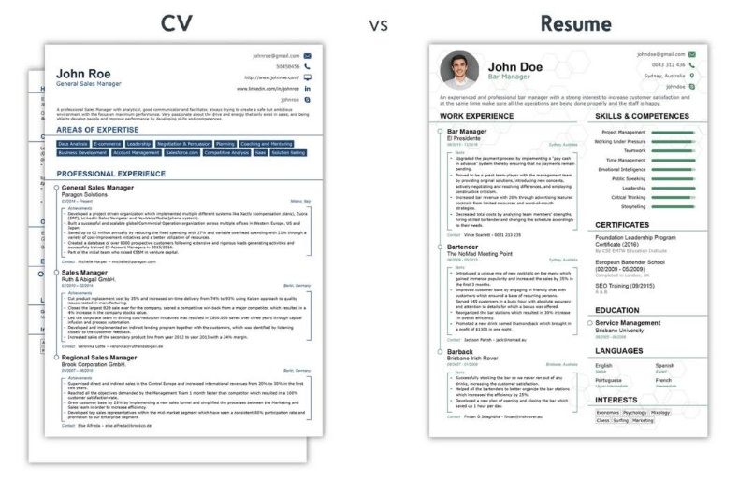

### Subsection Title 3

#### Sub-subsection Title 1

Spacing between title of subsection and first line of text is 1.5 lines. The first paragraph in a subsection should align with left margin. General alignment for texts in paragraph should be “justified”.

#### Sub-subsection Title 2

Spacing between title of subsection and first line of text is 1.5 lines. The first paragraph in a subsection should align with left margin. General alignment for texts in paragraph should be “justified”.

Spacing between paragraphs is 1.5 lines. Subsequence paragraphs should be indented 1.27 cm (0.5 inch) from the left margin. General alignment for texts in paragraph should be “justified”. Spacing between last line of text and the next subsection title is 4.5 lines.

#### Sub-subsection Title 3

Spacing between title of subsection and first line of text is 1.5 lines. The first paragraph in a subsection should align with left margin. General alignment for texts in paragraph should be “justified”.

### Subsection Title 4

Spacing between title of subsection and first line of text is 1.5 lines. The first paragraph in a subsection should align with left margin. Spacing between the last line of text and table is 1.5 lines.

**Table 2.2: Processing Time for Different Production Line**

|  |  |  |  |  |  |
| --- | --- | --- | --- | --- | --- |
| **Bread** | **Production Line** | | | | |
| **1** | **2** | **3** | **4** | **5** |
| **A** | 30 | 18 | 26 | 17 | 15 |
| **B** | 23 | 22 | 32 | 25 | 30 |
| **C** | 17 | 31 | 24 | 22 | 29 |

All figures must be numbered with respect to the chapter using Arabic numeric. For example, Figure 4.3 is the third figure that appears in Chapter 4. All figures must have a caption, which should be positioned at the bottom of the figure. Caption should be bold and written in Title Case. If the caption is written in a single line, it should be centred. If the caption is more than one line, it should be align to the left.



**Figure 2.1: University Malaysia of Computer Science and Engineering (UNIMY) Logo**

Spacing between figure caption and first line of text is 3.0 lines. Figure should be positioned after it has been cited for the first time in the text. All figures in the chapter can also be grouped together and positioned at an appropriate location. Figures which are presented in landscape format should be bound with the top of the figure to the spine.

## METHODOLOGY

### Subsection Title 1

Spacing between title of subsection and first line of text is 1.5 lines. The first paragraph in a subsection should align with left margin. General alignment for texts in paragraph should be “justified”.

Spacing between paragraphs is 1.5 lines. Subsequence paragraphs should be indented 1.27 cm (0.5 inch) from the left margin. General alignment for texts in paragraph should be “justified”. Spacing between last line of text and the next subsection title is 4.5 lines.

### Subsection Title 2

Spacing between title of subsection and first line of text is 1.5 lines. The first paragraph in a subsection should align with left margin. General alignment for texts in paragraph should be “justified”.

A new paragraph should not begin on the last line of a page. A subsection title should not begin on the last line of a page.

### Sub-subsection Title 1

#### Sub-sub-subsection Title 1

Spacing between title of subsection and first line of text is 1.5 lines. Spacing between the last line of text and table is 1.5 lines.

**Table 3.1: Processing Time (in hours) of Bread for Different Production Line**

|  |  |  |  |  |  |
| --- | --- | --- | --- | --- | --- |
| **Bread** | **Production Line** | | | | |
| **1** | **2** | **3** | **4** | **5** |
| **A** | 30 | 18 | 26 | 17 | 15 |
| **B** | 23 | 22 | 32 | 25 | 30 |
| **C** | 17 | 31 | 24 | 22 | 29 |

Spacing between the table and first line of text is 3.0 lines. Spacing between the last line of text and figure is 1.5 lines.

Source

Reflected

**Figure 3.1: Reflection from Smooth Surface**

Spacing between the figure and first line of text is 3.0 lines. Subsequence paragraphs should be indented 1.27 cm (0.5 inch) from the left margin.

## IMPLEMENTATION OF DESIGN

### Subsection Title 1

Spacing between title of subsection and first line of text is 1.5 lines. The first paragraph in a subsection should align with left margin. General alignment for texts in paragraph should be “justified” (Warner, 2002).

Spacing between paragraphs is 1.5 lines. Subsequence paragraphs should be indented 1.27 cm (0.5 inch) from the left margin. General alignment for texts in paragraph should be “justified”. Spacing between last line of text and the next subsection title is 4.5 lines.

### Subsection Title 2

Spacing between title of subsection and first line of text is 1.5 lines. The first paragraph in a subsection should align with left margin. General alignment for texts in paragraph should be “justified”.

A new paragraph should not begin on the last line of a page. A subsection title should not begin on the last line of a page. A new chapter must start on a new page.

### Sub-subsection Title 1

#### Sub-sub-subsection Title 1

Spacing between title of subsection and first line of text is 1.5 lines. The first paragraph in a subsection should align with left margin. Spacing between the last line of text and table is 1.5 lines.

**Table 4.1: Processing Time (in hours) of Bread for Different Production Line**

|  |  |  |  |  |  |
| --- | --- | --- | --- | --- | --- |
| **Bread** | **Production Line** | | | | |
| **1** | **2** | **3** | **4** | **5** |
| **A** | 30 | 18 | 26 | 17 | 15 |
| **B** | 23 | 22 | 32 | 25 | 30 |
| **C** | 17 | 31 | 24 | 22 | 29 |

Spacing between the table and first line of text is 3.0 lines. Spacing between the last line of text and figure is 1.5 lines.



**Figure 4.1: UNIMY Logo**

Spacing between the figure and first line of text is 3.0 lines. Subsequence paragraphs should be indented 1.27 cm (0.5 inch) from the left margin.

## CONCLUSION

### Subsection Title 1

Spacing between title of subsection and first line of text is 1.5 lines. The first paragraph in a subsection should align with left margin. General alignment for texts in paragraph should be “justified” (Warner, 2002).

Spacing between paragraphs is 1.5 lines. Subsequence paragraphs should be indented 1.27 cm (0.5 inch) from the left margin. General alignment for texts in paragraph should be “justified”. Spacing between last line of text and the next subsection title is 4.5 lines.

### Subsection Title 2

Spacing between title of subsection and first line of text is 1.5 lines. The first paragraph in a subsection should align with left margin. General alignment for texts in paragraph should be “justified”.

A new paragraph should not begin on the last line of a page. A subsection title should not begin on the last line of a page. A new chapter must start on a new page.

### Sub-subsection Title 1

#### Sub-sub-subsection Title 1

Spacing between title of subsection and first line of text is 1.5 lines. The first paragraph in a subsection should align with left margin. General alignment for texts in paragraph should be “justified”.

## REFERENCES

# *Resume*. (n.d.). Retrieved from Ginger: https://www.gingersoftware.com/content/writing-center/resume/

## APPENDICES

APPENDIX A: Graphs

Spacing between chapter title and first line of text is 4.5 lines. The first paragraph in a subsection should align with left margin. General alignment for texts in paragraph should be “justified”.

Spacing between paragraphs is 1.5 lines. Subsequence paragraphs should be indented 1.27 cm (0.5 inch) from the left margin. General alignment for texts in paragraph should be “justified”.

APPENDIX B: Computer Programme Listing

Spacing between chapter title and first line of text is 4.5 lines. The first paragraph in a subsection should align with left margin. General alignment for texts in paragraph should be “justified”.

Spacing between paragraphs is 1.5 lines. Subsequence paragraphs should be indented 1.27 cm (0.5 inch) from the left margin. General alignment for texts in paragraph should be “justified”.